Unit 4: (8 Hours)
Time Series Analysis: Objectives, Variations in Time Series. Measurement of Trend, Graphic Method, Moving Average Method, Semi-Average Method, Least Square Method. Measurement of Seasonal Variations- Method of Simple Averages, Ratio to Trend Method-Ratio to Moving Average

INTRODUCTION
The increasing complexity of the business environment together with changing demands and expectations, implies that every organization needs to know the future values of their key decision variables.
For example when the decision to build a new production facility is made, the demand for its products is not known with certainty.
Similarly, when a hospital chooses to add one more specialty healthcare wing, it needs to make some assumptions about the demand for the facility.
Managerial decision making is often complicated due to an element of uncertainty in the variables affecting the D-M process.
Since these decisions often involve considerable cash flow and time in creating new facilities, accurate estimates of the future events for which the decisions have been made are crucial. Therefore to address these issues managers use forecasting techniques to estimate the future.
At a more general level, forecasts are estimates of the timing and the magnitude of occurrence of future events.
Forecasting is essential to make reliable and accurate estimates of what will happen in the future in the face of uncertainty.
Key functions of forecasting
- An estimation tool
- A way of addressing the Complex and uncertain environment surrounding business decision making.
- A tool for predicting events related to operations planning and control
- A vital prerequisite for the planning process in uncertain environment

TIME SERIES ANALYSIS
A time series is a set of numerical values of some variable obtained at regular period over time. The series is usually tabulated or graphed in a manner that readily conveys the behavior of the variable under study.
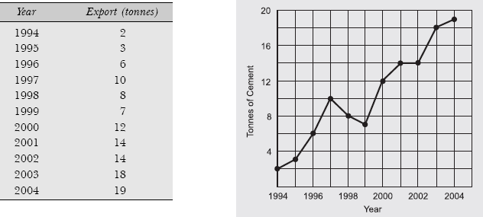
Figure above presents the export of cement (in tonnes) by a cement company between 1994 and 2004. The graph suggests that the series is time dependent. The management of the company is interested in determining how the series is dependent on time and in developing a means of predicting future levels with some degree of reliability. The nature of the time dependence is often analysed by decomposing the time series into its components.

Objectives of Time Series Analysis
- The assumption underlying time series analysis is that the future will look like the past, that is, the various factors which have already influenced the patterns of change in the value of the variable under study will continue to do so in more or less the same manner in the future. In other words, some underlying pattern exists in historical data.
Thus one of the objective of time-series analysis is to identify the pattern and isolate the influencing factors (or effects) for prediction purposes as well as for future planning and control.

- The review and evaluation of progress made on the basis of a plan are done on the basis of time-series data. For example the progress of Five-Year Plans is judged by the annual growth rates in the Gross National Product (GNP). Similarly the evaluation of our policy of controlling inflation and price rise is done by the study of various price indices which are based on the analysis of time-series.

Components of A Time Series (Decomposition of Time-Series)

The time-series data contain four components: trend, cyclicality, seasonality and irregularity.

Time-series: A set of observations measured at successive points in time or over successive periods of time.

Trend Sometimes a time-series displays a steady tendency of either upward or downward movement in the average (or mean) value of the forecast variable y over time. Such a tendency is called a trend. When observations are plotted against time, a straight line describes the increase or decrease in the time series over a period of time.

Trend: A type of variation in time-series that reflects a long-term movement in time-series over a long period of time.

Cycles An upward and downward movement in the variable value about the trend time over a time period are called cycles. A business cycle may vary in length, usually more than a year but less than 5 to 7 years. The movement is through four phases: from peak (prosperity) to contradiction (recession) to trough (depression) to expansion (recovery or growth) as shown in Fig.

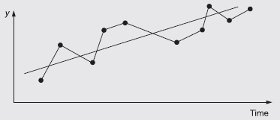
Variations in Time Series

Cyclical variation: A type of variation in time-series, in which the value of the variable fluctuates above and below a trend line and lasting more than one year.

Seasonal: It is a special case of a cycle component of time series in which fluctuations are repeated usually within a year (e.g. daily, weekly, monthly, quarterly) with a high degree of regularity. For example, average sales for a retail store may increase greatly during festival seasons.

Seasonal variation: A type of variation in time-series that shows a periodic pattern of change in time-series within a year; patterns tend to be repeated from year to year.

Irregular Irregular variations are rapid charges or bleeps in the data caused by short-term unanticipated and non-recurring factors. Irregular fluctuations can happen as often as day to day.
Irregular variation: A type of variation in time-series that reflects the random variation of the time-series values which is completely unpredictable.

QUANTITATIVE FORECASTING METHODS
The quantitative forecasting methods fall into two general categories:
- Time series methods
- Causal methods
The TIME SERIES METHODS are concerned with taking some observed historical pattern for some variable and projecting this pattern into the future using a mathematical formula. A time series is based on a sequence of evenly spaced (weekly, monthly, quarterly, and so on) data points. Examples include weekly : sales of Nike Air Jordans, quarterly earnings reports of Microsoft stock, daily shipments of Coors beer, and annual consumer price indices.
Time-series data implies that future values are predicted only from past values
A few time series methods such as freehand curves and moving averages simply describe the given data values, while other methods such as semi-average and least squares help to identify a trend equation to describe the given data values.

FREE HAND METHOD
A freehand curve drawn smoothly through the data values is often an easy and, perhaps, adequate representation of the data. From the figure below, it appears that a straight line connecting the 1994 and 2004 exports volumes is a fairly good representation of the given data.
The forecast can be obtained simply by extending the trend line

Example: Fit a trend line to the following data by using the freehand method.
Solution: Figure presents the freehand graph of sales turnover (Rs in lakh) form 1997 to 2004. Forecast can be obtained simply by extending the trend line. Figure Graph of Sales Turnover
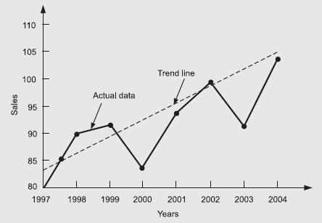

Limitations of freehand method
- This method is highly subjective because the trend line depends on personal judgment and therefore what happens to be a good-fit for one individual may not be so for another.
- It is very time-consuming to construct a freehand trend if a careful and conscientious job is to be done.

SMOOTHING METHODS
The objective of smoothing methods, smoothen out the random variations caused due to irregular components of the time series and thereby provide us with an overall impression of the pattern of movement in the data over time. Three smoothing methods:
- Moving averages
- Weighted moving averages
- Semi-averages
The data requirements for these techniques are minimal and these techniques are easy to use and understand.

MOVING AVERAGES
If we attempt to observe the movement of some variable values over a period of time and try to project this movement into the future, then it is essential to smooth out first the irregular pattern in the historical values of the variable, and later use this as the basis for a future projection. This can be done by using the technique of moving averages.
Moving averages: A quantitative method of forecasting or smoothing a time-series by averaging each successive group of data values.
This method is a subjective method and depends on the length of the period chosen for calculating moving averages. The period chosen should be an integer value and is a multiple of the estimated average length of a cycle in the series.
The moving averages which serve as an estimate of the next period's value of a variable given a period of length n is expressed as:
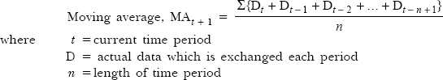
In this method, the term ‘moving’ is used because it is obtained by summing and averaging the values from a given number of periods, each time deleting the oldest value and adding a new value.
The major advantage of a moving average is the opportunity it provides to focus on the long-term trend (and cyclical) movements in a time series without the obscuring effect of short-term ‘noise’ influences.
The limitation of this method is that it is highly subjective and dependent on the length of period chosen for constructing the averages. Moving averages have the following three limitations:
- As the size of n (the number of periods averaged) increases, it smoothens the variations better, but it also makes the method less sensitive to real changes in the data.
- It is difficult to choose the optimal length of time for which to compute the moving average. Moving averages cannot be found for the first and last periods in a k-period moving average.
- Moving averages cannot pick-up trends very well. Since these are averages, it will always stay within past levels and will not predict a change to either a higher or lower level.
- It causes a loss of information (data values) at either end of the original time series.
- Moving averages do not usually adjust for such time-series effects as trend, cycle or seasonality.
Example: Shown is production volume (in ‘000 tonnes) for a product. Use these data to compute a 3-year moving average for all available years. Also determine the trend and short-term error.
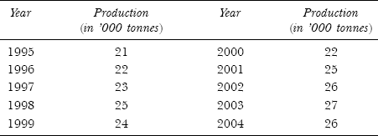
Solution: The first average is computed for the first 3 years as follows:
The first 3-year moving average can be used to forecast the production volume in fourth year, 1998. Because 25,000 tonnes production was made in 1998, the error of the forecast is Error₁₉₉₈ = 25,000 – 22,000 = 3000 tonnes.
Similarly, the moving average calculation for the next 3 years is:
A complete summary of 3-year moving average calculations is given in Table
Table Calculation of Trend and Short-term Fluctuations
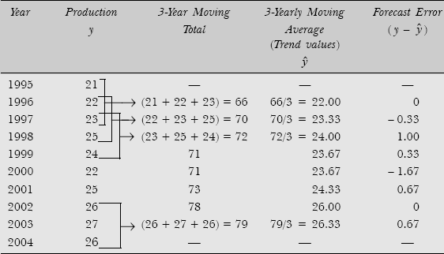
Example: Assume a four-year cycle and calculate the trend by the method of moving average from the following data relating to the production of tea in India:
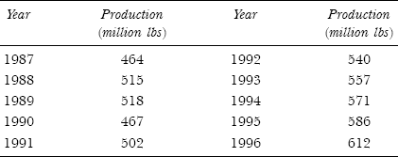
Solution: The first 4-year moving average is:
This moving average is centred on the middle value, that is, the third year of the series.
Similarly,
This moving average is centred on the fourth year of the series
Table presents the data along with the computations of 4-year moving averages.
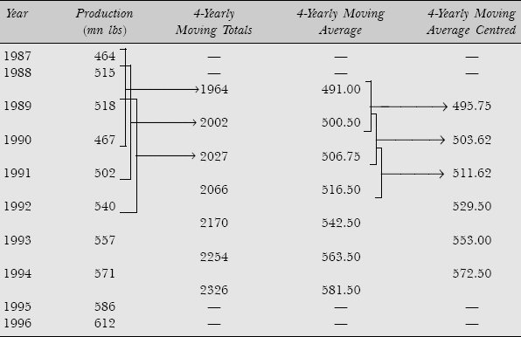

Weighted Moving Averages
In moving averages, each observation is given equal importance (weight). However, it may be desired to place more weight (importance) on certain periods of time than on others. So a moving average in which some time periods are weighted differently than others is called a weighted moving average
Weighted moving average: A quantitative method of forecasting or smoothing a time-series by computing a weighted average of past data values; sum of weights must equal one.
A weighted moving average is computed as:

Example Vacuum cleaner sales for 12 months is given below. The owner of the supermarket decides to forecast sales by weighting the past three months as follows
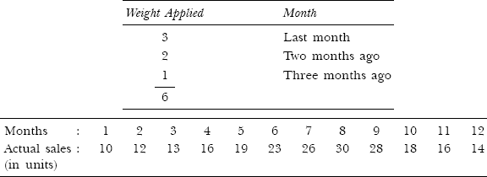
Solution: The results of 3-month weighted average are shown in Table
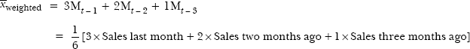
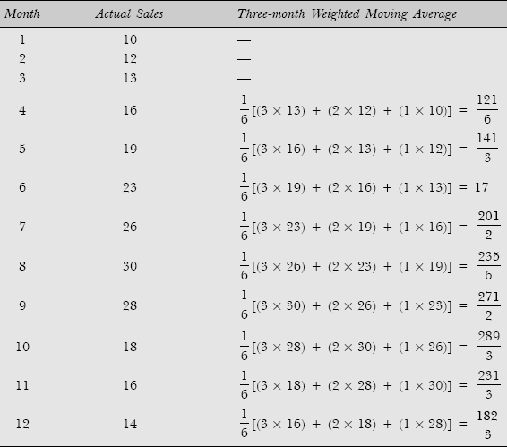

Example: A food processor uses a moving average to forecast next month's demand. Past actual demand (in units) is shown below:
- Compute a simple five-month moving average to forecast demand for month 52.
- Compute a weighted three-month moving average where the weights are highest for the latest months and descend in order of 3, 2, 1.
Solution: Calculations for five-month moving average are shown Table
Table Five-month Moving Average
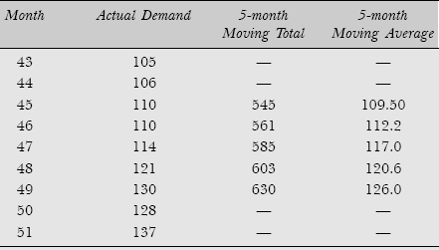
(a) Five-month average demand for month 52 is
(b) Weighted three-month average as per weights is as follows:
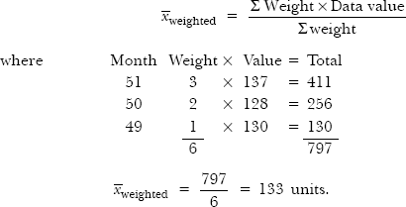

SEMI-AVERAGE METHOD
The semi-average method permits us to estimate the slope and intercept of the trend line quite easily. The resultant is a time series of the form : 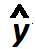 = a + bx. The is the calculated trend value and a and b are the intercept and slope values respectively. The equation should always be stated completely with reference to the year where x = 0 and a description of the units of x and y.

LINEAR TREND MODEL
The METHOD OF LEAST SQUARES from regression analysis is used to find the trend line of best fit to a time series data. The regression trend line (y) is defined by the following equation.
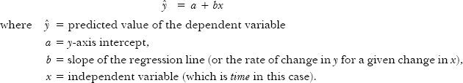
For linear equations, it is found by the simultaneous solution for a and b of the two normal equations:
where the data can be coded so that ∑x = 0, two terms in these equations drop out and we have
Coding is easily done with time-series data. For coding the data, we choose the centre of the time period as x = 0 and have an equal number of plus and minus periods on each side of the trend line which sum to zero.
Alternately, we can also find the values of constants a and b for any regression line as:
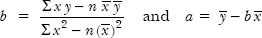
MEASUREMENT OF SEASONAL EFFECTS
Seasonal effect is defined as the repetitive and predictable pattern of data behaviour in a time-series around the trend line during particular time intervals of the year. In order to measure (or detect) the seasonal effect, time period must be less than one year such as days, weeks, months, or quarters.
Seasonal effects arises as the result of natural changes in the seasons during the year or may result due to habits, customs, or festivals that occur at the same time year after year.
We have three main reasons to study seasonal effects:
- The description of the seasonal effect provides a better understanding of the impact this component has upon a particular time-series.
- Once the seasonal pattern that exists is established, seasonal effect can be eliminated from the time-series in order to observe the effect of the other components, such as cyclical and irregular components. Elimination of seasonal effect from the series is referred to as deseasonalizing or seasonal adjusting of the data.
- Trend analysis may be adequate for long-range forecast, but for short-run predictions, knowledge of seasonal effects on time-series data is essential for projection of past pattern into the future.
De-seasonalization: A statistical process used to remove the effect of seasonality from a time series by dividing each original series observation by the corresponding seasonal index.

SEASONAL INDEX
Seasonal effects are measured in terms of an index, called seasonal index, attached to each period of the time series within a year. Hence, if monthly data are considered, there are 12 separate seasonal indexes, one for each month. Similarly for quarterly data, there are 4 separate indexes. A seasonal index is an average that indicates the percentage deviation of actual values of the time series from a base value which excludes the short-term seasonal influences. The base time series value represents the trend/cyclical influences only.
The following four methods are used to construct seasonal indexes to measure seasonal effects in the time-series data:
- Method of simple averages
- Ratio-to-trend method
- Ratio-to-moving average method

METHOD OF SIMPLE AVERAGES
This method is also called average percentage method because this method expresses the data of each month or quarter as a percentage of the average of the year. The steps of the method are summarized below:
- Average the unadjusted data by years and months (or quarters if quarterly data are given).
- Add the figures of each month and obtain the averages by dividing the monthly totals by the number of years. Let the averages for 12 months be denoted by ₁, ₂,…, ₁₂.
- Obtain an average of monthly averages by dividing the total of monthly averages by 12. That is
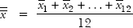

- Compute seasonal indexes for different months by expressing monthly averages as percentages of the grand average as follows:
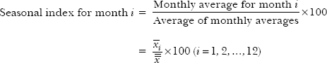

It is important to note that the average of the indexes will always be 100, that is, sum of the indexes should be 1200 for 12 months, and sum should be 400 for 4 quarterly data. If the sum of these 12 months percentages is not 1200, then the monthly percentage so obtained are adjusted by multiplying these by a suitable factor [1200 ÷ (sum of the 12 values)].

Example: Use the method of monthly averages to determine the monthly indexes for the data of production of a commodity for the years 2002 to 2004.
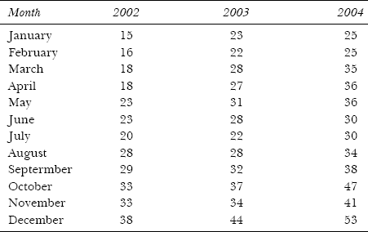
Solution: Computation of seasonal index by average percentage method based on the data is shown in Table .
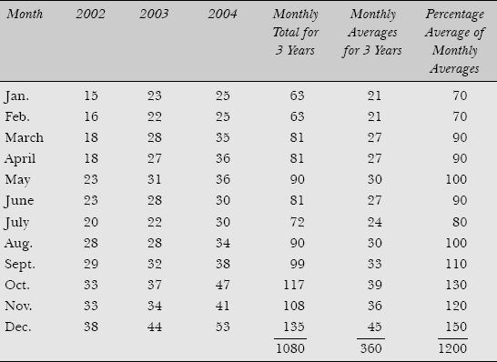

The average of monthly averages is obtained by dividing the total of monthly averages by 12. In column 7 each monthly average for 3 years have been expressed as a percentage of the averages. For example, the percentage for January is:
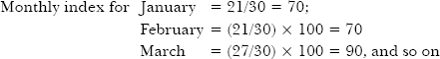

Example: The data on prices (Rs in per kg) of a certain commodity during 2000 to 2004 are shown below:
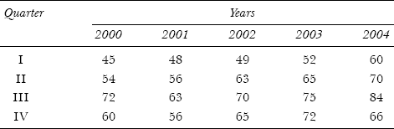

Compute the seasonal indexes by the average percentage method and obtain the deseasonalized values. Solution: Calculations for quarterly averages are shown in Table .
Table Calculation Seasonal Indexes
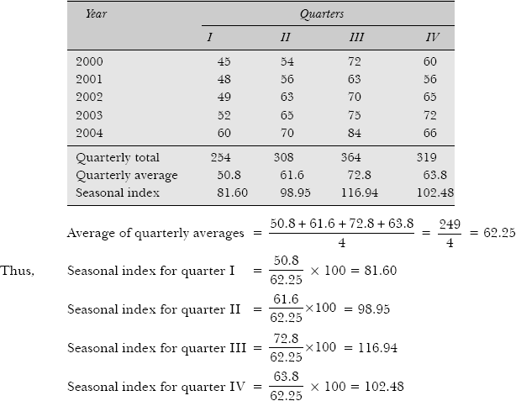
Deseasonalized Values Seasonal influences are removed from a time-series data by dividing the actual y value for each quarter by its corresponding seasonal index:
The deseasonalized y values which are measured in the same unit as the actual values, reflect the collective influence of trend, cyclical and irregular forces. The deseasonalized values are given in Table Calculation for Least Squares Equation
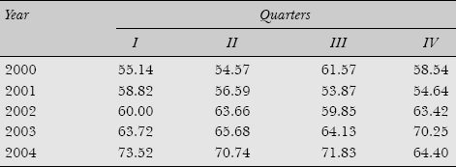

RATIO-TO-TREND METHOD
This method is also known as the percentage trend method. This method is an improvement over the method of simple averages. Because here it is assumed that seasonal variation for a given month is a constant fraction of trend. The ratio-to-trend method isolates the seasonal factor when the following ratios are computed:
Example: Quarterly sales data (Rs in million) in a super bazar are presented in the following table for a four-year period
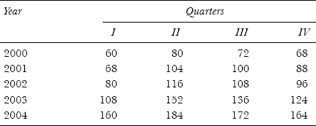
Calculate the seasonal index for each of the four quarters using the ratio-to-trend method.
Solution: Calculations to obtain annual trend values from the given quarterly data using the method of least-squares are shown in Table .
Table Calculation of Trend Values
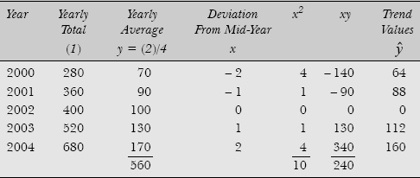
Solving the following normal equations, we get
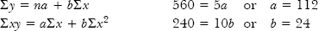
Thus the yearly fitted trend line is: y = 112 + 24x. The value of b = 24 indicates yearly increase in sales. Thus the quarterly increment will be 24/4 = 6.
To calculate quarterly trend values, consider first the year 2000. The trend value for this year is 64. This is the value for the middle of the year 2000, that is, half of the 2nd quarter and half of the 3rd quarter. Since quarterly increment is 6, the trend value for the 2nd quarter of 2000 would be 64 – (6/2) = 61 and for the 3rd quarter it would be 64 + (6/2) = 67. The value for the 1st quarter of 2000 would be 61 – 6 = 55 and for the 4th quarter it would be 67 + 6 = 73. Similarly, trend values of the various quarters of other years can be calculated as shown in Table .
Table Quarterly Trend Values
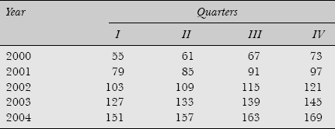
After getting the trend values, the given data values in the time-series are expressed as percentages of the corresponding trend values in Table. Thus for the 1st quarter of 2000, this percentage would be (60/55) × 100 = 109.09; for the 2nd quarter it would be (80/61) × 100 = 131.15, and so on. Other values can be calculated in the same manner as shown in Table 16.17.

Table Ratio-to-Trend Values
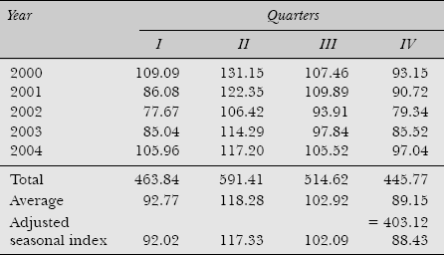
The total of average of seasonal indexes is 403.12 (>400). Thus we apply the correction factor (400/403.12) = 0.992. Now each quarterly average is multiplied by 0.992 to get the adjusted seasonal index as shown in Table .
The seasonal index 92.02 in the first quarter means that on average sales trend to be depressed by the presence of seasonal forces to the extent of approx. (100 – 92.02) = 7.98%. Alternatively, values of time series would be approx. (7.98/92.02)×100 = 8.67% higher had seasonal influences not been present.

RATIO-TO-MOVING AVERAGE METHOD
This method is also called the percentage moving average method. In this method, the original values in the time-series data are expressed as percentages of moving averages instead of percentages of trend values in the ratio-to-trend method. The steps of the method are summarized as follows:
- Find the centred 12 monthly (or 4 quarterly) moving averages of the original data values in the time-series.
- Express each original data value of the time-series as a percentage of the corresponding centred moving average values obtained in Step (i). In other words, in a multiplicative time-series model, we get

This implies that the ratio-to-moving average represents the seasonal and irregular components.
- Arrange these percentages according to months or quarter of given years. Find the averages over all months or quarters of the given years.
- If the sum of these indexes is not 1200 (or 400 for quarterly figures), multiply them by a correction factor = 1200/(sum of monthly indexes). Otherwise, the 12 monthly averages will be considered as seasonal indexes.
Example: Calculate the seasonal index by the ratio-to-moving method from the following data:
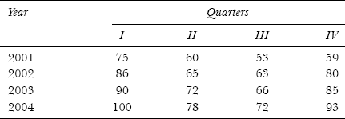
Solution: Calculations for 4 quarterly moving averages and ratio-to-moving averages are shown in Table .
Table Calculation of Ratio-to-Moving Averages
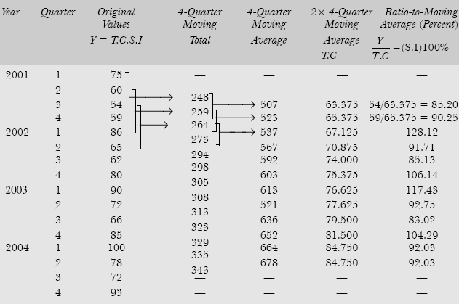

Table Calculation of Seasonal Index
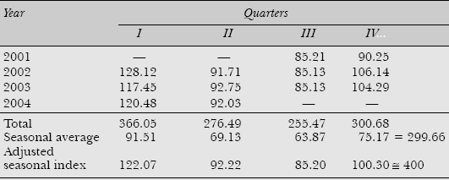
The total of seasonal averages is 299.66. Therefore the corresponding correction factor would be 400/299.68 = 1.334. Each seasonal average is multiplied by the correction factor 1.334 to get the adjusted seasonal indexes shown in Table .
Example: Calculate the seasonal indexes by the ratio-to-moving average method from the following data:
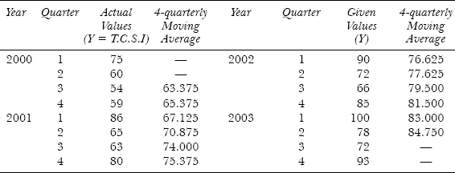
Solution: Calculations of ratio-to-moving averages are shown in Table .
Table Calculation of Seasonal Indexes
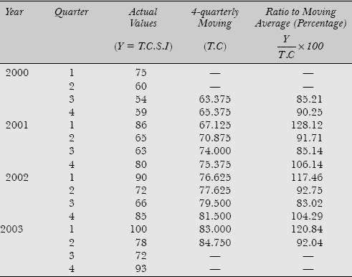
Rearranging the percentages to moving averages, the seasonal indexes are calculated as shown in Table .
Table Seasonal Indexes
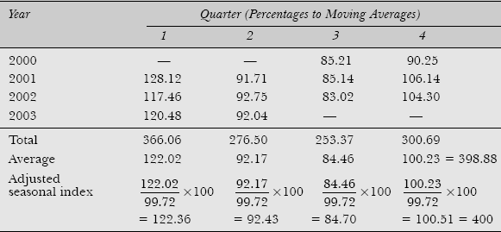
Since the total of average indexes is less than 400, the adjustment of the seasonal index has been done by calculating the grand mean value as follows:
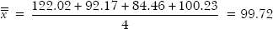
The seasonal average values are now converted into adjusted seasonal indexes using = 99.72 as shown in Table .

